North Wingfield Medical Centre

New Patient Questionnaire – Adult Please complete all pages in full using block capitals

1. Background Details

Contact Details
NHS Number |  |  |  | If you have had a previous GP then you will find this on letters/prescriptions or at www.nhs.uk/find-NHS-number
 | I do not know my NHS number
Name |  |  |  | Gender
Which of the following best describes how you think of yourself? | Non-binary Female Male Prefer not to say Unable to answer
Is your gender the same as the sex you were assigned at birth? | Yes Prefer not to say  No Unable to answer
Previous Surname
(if applicable)
Address |  |  |  | Date of Birth
Address |  |  |  | Home Telephone
Address |  |  |  | Work Telephone
Previous Address
Mobile Telephone | I consent to be contacted* by SMS on this number:
Email | I consent to be contacted* by email at this address:
Next of Kin | Name: |  | Tel: |  | Relationship:
Family Registered With Us
Has the patient been registered in the NHS before? Yes No
If no please state the date entered UK:

* It is your responsibility to keep us updated with any changes to your telephone number, email & postal address.
We may contact you with appointment details, test results, health campaigns or Patient Participation Group details
If you do not consent to being contacted by SMS or Email, please tick here: SMS Email

Other Details
Previous GP | Name: |  | Address:
Country of Birth
Ethnicity | White (UK)  White (Irish)  White (Other) | Black Caribbean  Black African  Black Other |  | Bangladeshi  Indian  Pakistani | Chinese  Other
Religion | C of E  Catholic  Other Christian | Buddhist  Hindu  Muslim |  | Sikh  Jewish  Jehovah’s Witness | No religion  Other:
Housing | Own House  Rented House  Shared House | Nursing Home  Residential Home  Sheltered Home |  | Homeless  Housebound | Asylum Seeker  Refugee
Employment | Employed  Self-employed | Student  Unemployed |  | House husband  Housewife | Carer  Retired
Overseas Visitor | Yes | European Health Insurance Card Held (please bring details with you)
Armed Forces | Military Veteran | Family member

Communication Needs
Language | What is your main spoken language?  Do you need an interpreter? Yes No
Communication | Do you have any communication needs? Yes No (If Yes please specify below)
Communication | Hearing aid  Lip-reading | Large print  Braille | British Sign Language  Makaton Sign Language Guide dog
How well do you use a mobile phone or the internet to communicate with your GP Practice? (Please tick) | I am able to use Information Technology to communicate with my Practice
 | I have difficulty using Information Technology to communicate with my Practice
 | I am unable to use Information Technology
Reasonable Adjustments | Are there any other Reasonable Adjustments you would like to tell us about?  https://www.england.nhs.uk/learning-disabilities/improving-health/reasonable-adjustments/  Yes No  If Yes, please tell us about what reasonable adjustments you may need  Do you consent for a digital flag communicating these reasonable adjustments to be electronically added to your medical record?  Yes No
Learning disability | Do you have a Learning Disability? Yes No  (If Yes please request a Learning Disability Screening Tool form)
Consent | Do you consent to a digital flag being added to your record communicating the above needs? Yes No

Carer Details
Are you a carer? | Yes – Informal / Unpaid Carer |  | Yes – Occupational / Paid Carer |  | No
Do you have a carer? | Yes | Name*: | Tel: | Relationship:
* Only add carer’s details if they give their consent to have these details stored on your medical record

2. Medical History

Medical History
Have you suffered from any of the following conditions?
Asthma  COPD  Epilepsy | Heart Disease  Heart Failure  High Blood Pressure | Diabetes  Kidney Disease  Stroke | Depression  Underactive Thyroid  Cancer- Type:
Any other conditions, operations or hospital admission details:

If you are currently under the care of a Hospital or Consultant outside our area, please tell us here:

Family History
Please record any significant family history of close relatives with medical problems and confirm which relative e.g. mother, father, brother, sister, grandparent
Asthma…………………  COPD………………...  Epilepsy……………… | Heart Disease……….  Stroke…………….…..  Blood Pressure……… | Diabetes………..………  Kidney Disease..………  Liver Disease..….…….. | Depression……..……  Thyroid…………...…..  Cancer………………..
Other:

Allergies
Please record any allergies or sensitivities below

Vaccinations
Have you had all your routine vaccinations? Yes No

Did you receive all your routine vaccinations in the UK? Yes No

Current Medication
Please check and include as much information about your current medication below
Please give us your previous repeat medication list if possible and a medication review appointment may be needed

3. Your Lifestyle

Alcohol
Please answer the following questions which are validated as screening tools for alcohol use:
 | Scoring System |  |  |  |  | Your Score
 | 0 | 1 | 2 | 3 | 4 | Your Score
How often do you have a drink containing alcohol? | Never | Monthly or Less | 2-4 times per month | 2-3 times per week | 4+ times per week
How many units of alcohol do you drink on a typical day when you are drinking? | 1-2 | 3-4 | 5-6 | 7-9 | 10+
How often have you had 6 or more units if female, or 8 or more if male, on a single occasion in the last year? | Never | Less than monthly | Monthly | Weekly | Daily or almost daily
A score of less than 5 indicates lower risk drinking |  |  |  |  | TOTAL:
Scores of 5 or more requires the following 7 questions to be completed:
 | Scoring System |  |  |  |  | Your Score
 | 0 | 1 | 2 | 3 | 4 | Your Score
How often during the last year have you found that you were not able to stop drinking once you had started? | Never | Less than monthly | Monthly | Weekly | Daily or almost daily
How often during the last year have you failed to do what was normally expected from you because of your drinking? | Never | Less than monthly | Monthly | Weekly | Daily or almost daily
How often during the last year have you needed an alcoholic drink in the morning to get yourself going after a heavy drinking session? | Never | Less than monthly | Monthly | Weekly | Daily or almost daily
How often during the last year have you had a feeling of guilt or remorse after drinking? | Never | Less than monthly | Monthly | Weekly | Daily or almost daily
How often during the last year have you been unable to remember what happened the night before because you had been drinking? | Never | Less than monthly | Monthly | Weekly | Daily or almost daily
Have you or somebody else been injured as a result of your drinking? | No |  | Yes, but not in last year |  | Yes, during last year
Has a relative or friend, doctor or other health worker been concerned about your drinking or suggested that you cut down? | No |  | Yes, but not in last year |  | Yes, during last year
 |  |  |  |  | TOTAL:
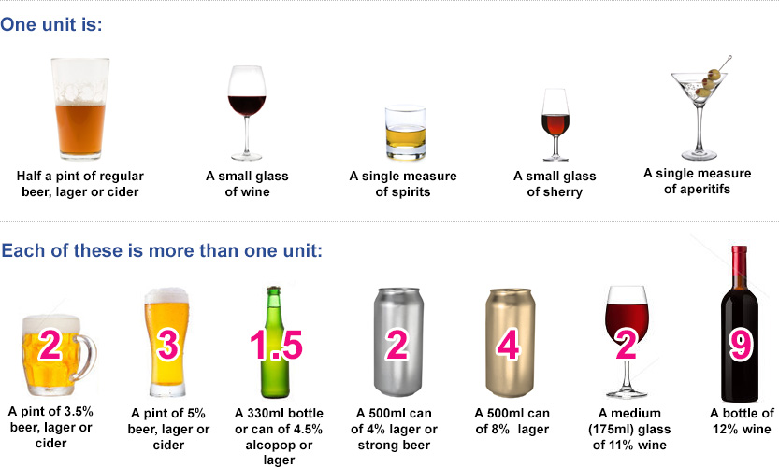

Smoking
Do you smoke? | Never smoked | Ex-smoker | Yes
Do you use an e-Cigarette? | No | Ex-User | Yes
How many cigarettes did/do you smoke a day? | Less than one | 1-9 10-19 | 20-39 40+
Would you like help to quit smoking? | Yes | No
 | For further information, please see: www.nhs.uk/smokefree

Height & Weight
Height
Weight
Waist Circumference
Blood Pressure (if known)

Women Only
Do you use any contraception?  Do you have a coil or implant in situ? | Yes No If needed, please book appointment.  Yes No Date inserted:
Are you currently pregnant or think you may be? | Yes No Expected due date:

Students Only
Students are at risk of certain infections including mumps, meningitis and sexually transmitted infections, as well as mental health issues including stress, anxiety and depression. Please see www.nhs.uk/Livewell/Studenthealth
I am less than 24 years old and have had two doses of the MMR Vaccination | Yes | No | Unsure
I am less than 25 years old and have had a Meningitis C Vaccination | Yes | No | Unsure

4. Further Details

Named Accountable GP
The GP who has overall responsibility for your care is?
You are however entitled to make an appointment to see any GP of your choice, subject to availability.

Electronic Prescribing
If you would like your prescriptions to be sent electronically,  please provide details of the pharmacy you would like to use: | Pharmacy:

Patient Participation Group
Would you like to be involved in our Patient Participation Group? | Yes No
We are committed to improving the services we provide. The Patient Participation Group is a mechanism for us to gain valuable feedback from our patients about their experiences, views and ideas for improving our services.

Blood and Organ Donation
Blood Donation | If you are interested in blood donation and would like to register as a blood donor, please visit https://www.blood.co.uk/
Organ Donation | If you are interested in organ donation and would like to register your decision, please visit: https://www.organdonation.nhs.uk/

Signatures
Signature | I confirm that the information I have provided is true to the best of my knowledge.  Signed on behalf of patient
Name
Date

Checklist
Please ensure the following are done and provided so that your registration can be completed successfully
Completed & Signed New Patient Questionnaire
Completed & Signed Registration Form

5. Sharing Your Health Record

Your Health Record
Do you consent to your GP Practice sharing your health record with other organisations who care for you?

Yes (recommended option)
No, never

Do you consent to your GP Practice viewing your health record from other organisations that care for you?

Yes (recommended option)
No

Your Summary Care Record (SCR)
Do you consent to having an Enhanced Summary Care Record with Additional Information?

Yes (recommended option)
No

Signature
Signature
Signed on behalf of patient
Name
Date

Sharing Your Health Record

What is your health record?
Your health record contains all the clinical information about the care you receive. When you need medical assistance it is essential that clinicians can securely access your health record. This allows them to have the necessary information about your medical background to help them identify the best way to help you. This information may include your medical history, medications and allergies.

Why is sharing important?
Health records about you can be held in various places, including your GP practice and any hospital where you have had treatment. Sharing your health record will ensure you receive the best possible care and treatment wherever you are and whenever you need it. Choosing not to share your health record could have an impact on the future care and treatment you receive. Below are some examples of how sharing your health record can benefit you:

- Sharing your contact details This will ensure you receive any medical appointments without delay
- Sharing your medical history This will ensure emergency services accurately assess you if needed
- Sharing your medication list This will ensure that you receive the most appropriate medication
- Sharing your allergies This will prevent you being given something to which you are allergic
- Sharing your test results This will prevent further unnecessary tests being required

Is my health record secure?
Yes. There are safeguards in place to make sure only organisations you have authorised to view your records can do so. You can also request information regarding who has accessed your information from both within and outside of your surgery.

Can I decide who I share my health record with?
Yes. You decide who has access to your health record. For your health record to be shared between organisations that provide care to you, your consent must be gained.

Can I change my mind?
Yes. You can change your mind at any time about sharing your health record, please just let us know.

Can someone else consent on my behalf?
If you do not have capacity to consent and have a Lasting Power of Attorney, they may consent on your behalf. If you do not have a Lasting Power of Attorney, then a decision in best interests can be made by those caring for you.

What about parental responsibility?
If you have parental responsibility and your child is not able to make an informed decision for themselves, then you can make a decision about information sharing on behalf of your child. If your child is competent then this must be their decision.

What is your Summary Care Record?
Your Summary Care Record contains basic information including your contact details, NHS number, medications and allergies. This can be viewed by GP practices, Hospitals and the Emergency Services. If you do not want a Summary Care Record, please ask your GP practice for the appropriate opt out form. With your consent, additional information can be added to create an Enhanced Summary Care Record. This could include your care plans which will help ensure that you receive the appropriate care in the future.

How is my personal information protected?
North Wingfield Medical Centre will always protect your personal information. For further information about this, please see our Privacy Notice on our website or please speak to a member of our team

For further information about your health records, please see: https://www.nhs.uk/using-the-nhs/about-the-nhs/your-health-records/
For further information about how the NHS uses your data for research & planning and to opt-out, please see: www.nhs.uk/your-nhs-data-matters

